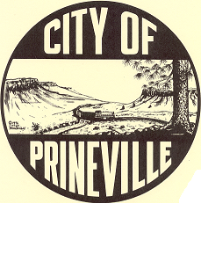
City of Prineville

Department of Planning & Community Development

Staff Report

Prineville Planning Commission Meeting
November 20, 2007

Topic: State mandated Comprehensive Plan revisions

Departments: Planning
Staff: Ricky Sites, D. McMahon, Scott Edelman, Joshua Smith

Overview: DLCD completed there review of Prineville’s Comprehensive Plan and ordered that two changes be made to the document as attached. These changes are minor and have no substantive effect on the overall document or its intent.

Staff Recommendation: Staff concurs with DLCD and recommends that the Planning Commission recommend approval of these changes to the Prineville City Council.

Page 36
Goal # 2: Update the UGB boundary when necessary.

Urban Growth Boundary and Policies

- The UGB must include all of the land needed for residential, industrial, and commercial development for at least a 20-year period.
…
Programs:

The City shall:
…
- Maintain adequate levels of residential, commercial, industrial, and recreation lands for at least a 20-year period.

Page 122

